New SEEK Application Process!
- Go online to www.pbcregistry.org and click on “Registry Login”
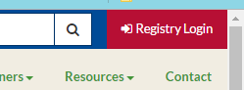
- Enter your Registry ID and Password to Sign In
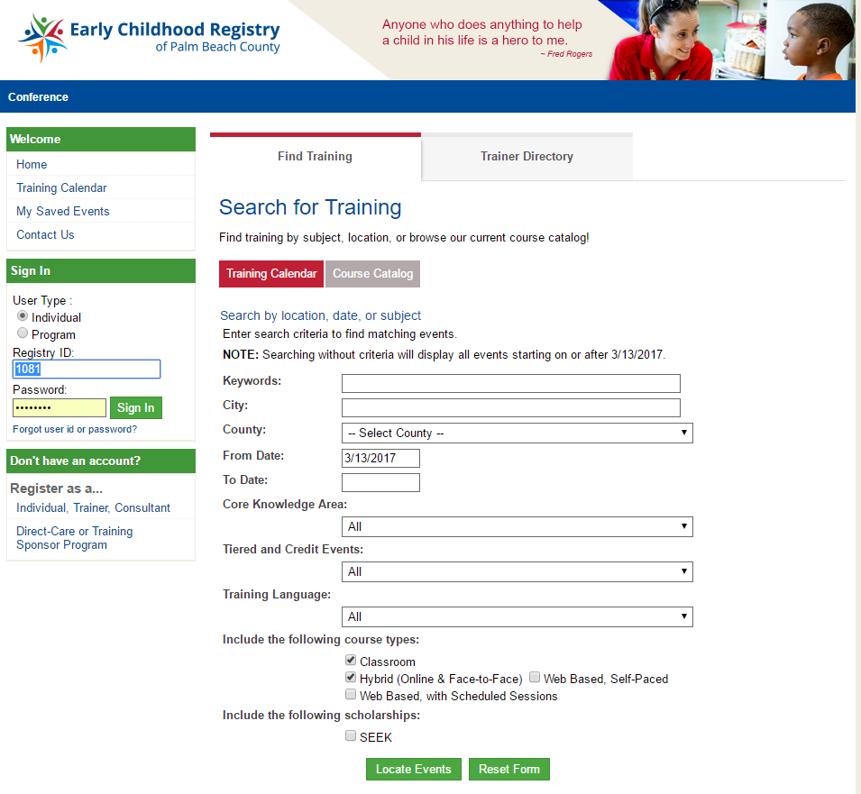
- Click on the green SEEK tab on the far right and click on “Apply for SEEK”.
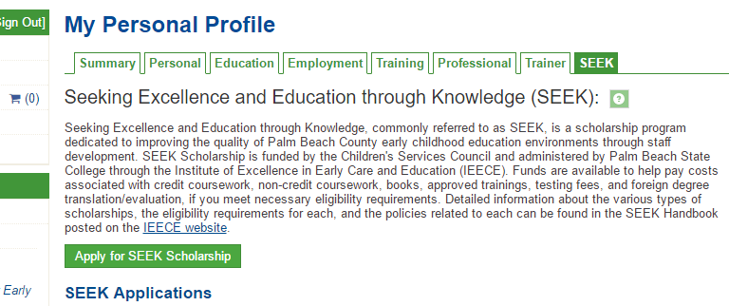
- Select “Community Based Training / Registry Approved Career Pathway Training”.
- Use the “Event ID” to locate training.
- If you are unable to upload documents, please fax supporting documentation to (561) 868-7042 or email to IEECE@palmbeachstate.edu
- Call 561-868-3670 to be connected to your assigned Career Advisor who can assist you by phone or in person.

